Charlie Nitschelm

4/7/19

ME 647

Engine Lab

Contents

Table of Figures 1

Optical Sensor Voltage, Crank Angle, Cylinder Volume, and Pressure 2

Pressure vs. Cylinder Volume for a Single Cycle 8

Pressure vs. Cylinder Volume for all Cycles 14

Average Work and Power / Cycle / Cylinder for Various Engine Speeds 20

Engine Parameters 20

Brake Torque and Power with Engine Speed 21

Brake Thermal Efficiency with Various Engine Speeds 22

Mass Flow Rate with Different Engine Speeds 23

# Table of Figures

Figure 1 - Experimental Data for the Kohler Model CH20S SI Engine at 600RPM 2

Figure 2 - Experimental Data for the Kohler Model CH20S SI Engine at 700RPM 3

Figure 3 - Experimental Data for the Kohler Model CH20S SI Engine at 800RPM 4

Figure 4 - Experimental Data for the Kohler Model CH20S SI Engine at 900RPM 5

Figure 5 - Experimental Data for the Kohler Model CH20S SI Engine at 1000RPM 6

Figure 6 - Experimental Data for the Kohler Model CH20S SI Engine at 1100RPM 7

Figure 7 - Cylinder pressure vs. cylinder volume at 600 RPM for a single cycle 8

Figure 8 - Cylinder pressure vs. cylinder volume at 700 RPM for a single cycle 9

Figure 9 - Cylinder pressure vs. cylinder volume at 800 RPM for a single cycle 10

Figure 10 - Cylinder pressure vs. cylinder volume at 900 RPM for a single cycle 11

Figure 11 - Cylinder pressure vs. cylinder volume at 1000 RPM for a single cycle 12

Figure 12 - Cylinder pressure vs. cylinder volume at 1100 RPM for a single cycle 13

Figure 13 - Cylinder pressure vs. cylinder volume at 600 RPM for all cycles 14

Figure 14 - Cylinder pressure vs. cylinder volume at 700 RPM for all cycles 15

Figure 15 - Cylinder pressure vs. cylinder volume at 800 RPM for all cycles 16

Figure 16 - Cylinder pressure vs. cylinder volume at 900 RPM for all cycles 17

Figure 17 - Cylinder pressure vs. cylinder volume at 1000 RPM for all cycles 18

Figure 18 - Cylinder pressure vs. cylinder volume at 1100 RPM for all cycles 19

Figure 19 - Brake Torque and Power Values with different Rotational Engine Speeds 21

Figure 20 - The Brake Thermal Efficiency of the engine at different engine speeds 22

Figure 21 - Mass flow rate of the engine at different rotational speeds in kg/s 23

Figure 22 - Mass flow rate of the engine at different rotational speeds in kg/cycle/cylinder 24

# Optical Sensor Voltage, Crank Angle, Cylinder Volume, and Pressure

The following figures detail the Crank Angle position, the cylindrical volume, and the pressure of the cylinder with respect to time for various rotational speeds of the Kohler Model CH20S SI Engine.

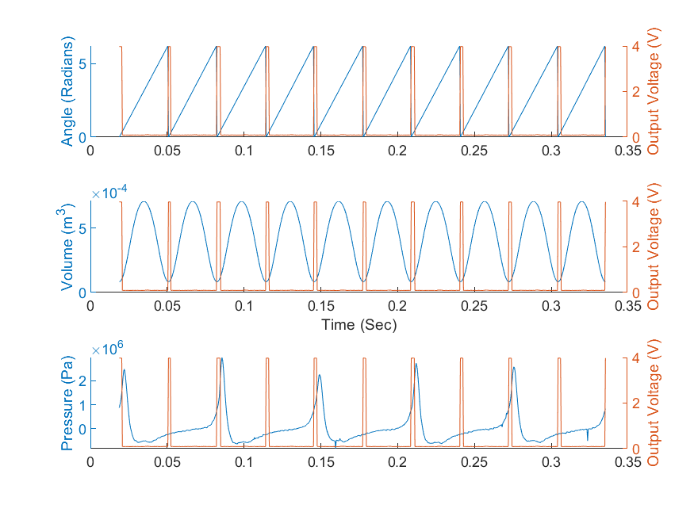

Figure 1 - Experimental Data for the Kohler Model CH20S SI Engine at 600RPM

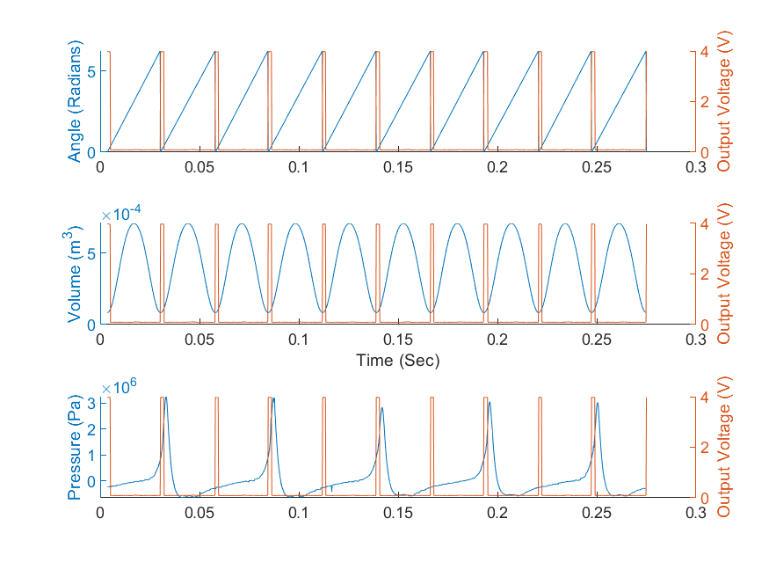

Figure 2 - Experimental Data for the Kohler Model CH20S SI Engine at 700RPM

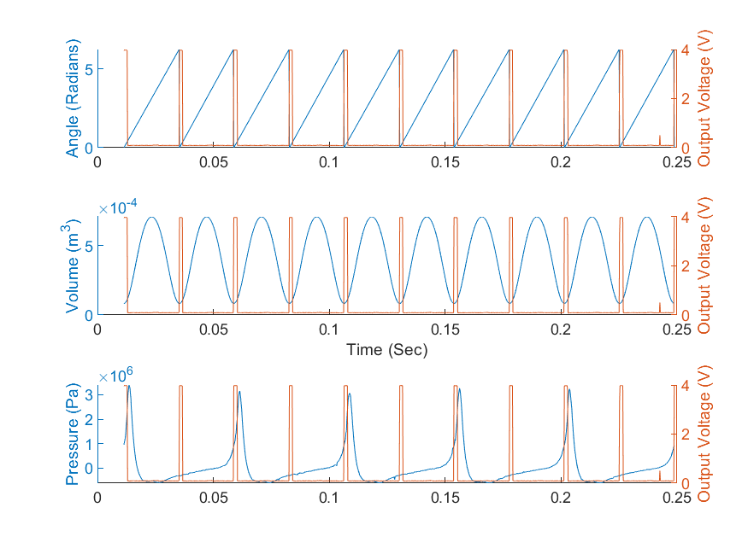

Figure 3 - Experimental Data for the Kohler Model CH20S SI Engine at 800RPM

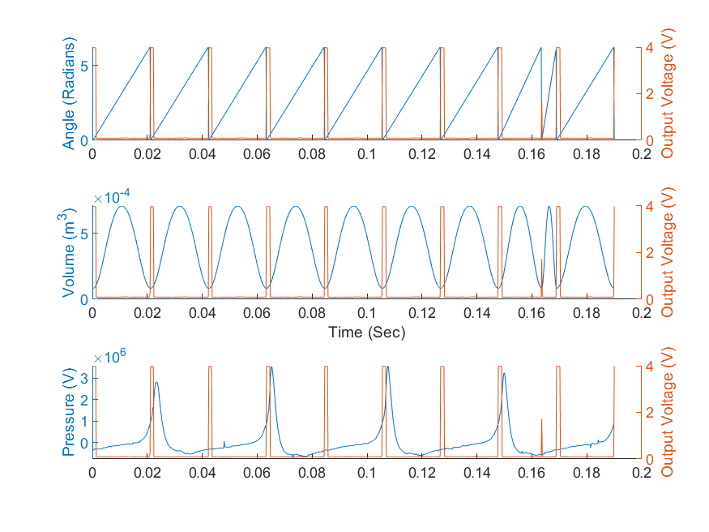

Figure 4 - Experimental Data for the Kohler Model CH20S SI Engine at 900RPM

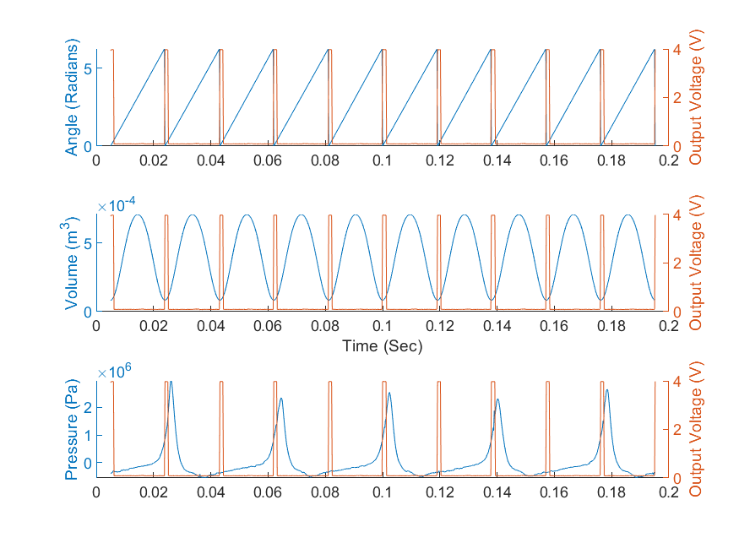

Figure 5 - Experimental Data for the Kohler Model CH20S SI Engine at 1000RPM

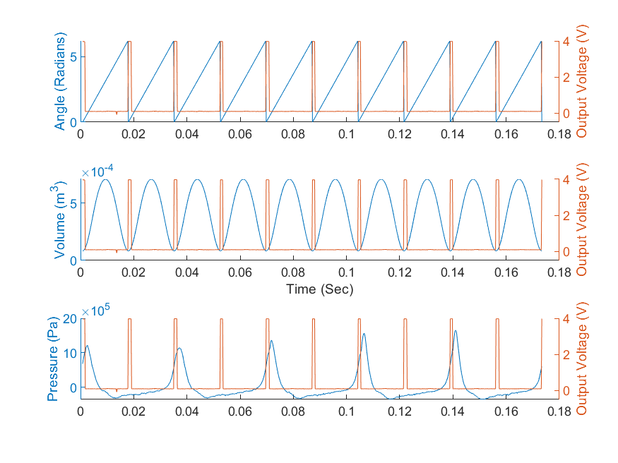

Figure 6 - Experimental Data for the Kohler Model CH20S SI Engine at 1100RPM

# Pressure vs. Cylinder Volume for a Single Cycle

The following graphs detail a single cycle of the engine at various engine speeds.

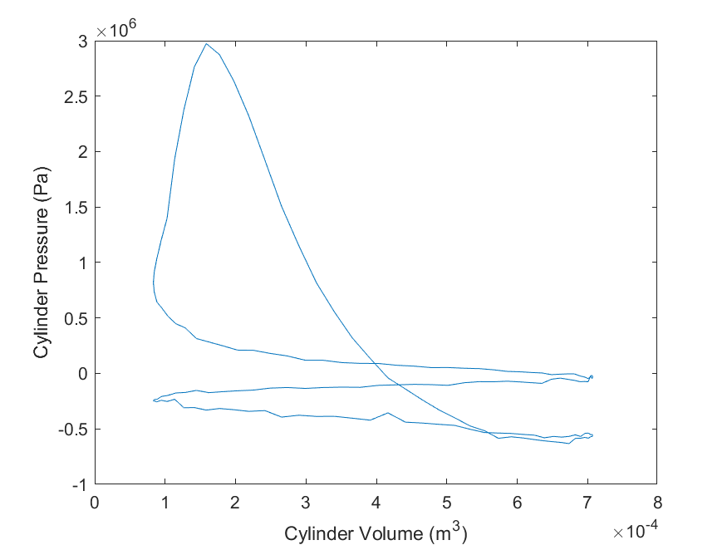

Figure 7 - Cylinder pressure vs. cylinder volume at 600 RPM for a single cycle

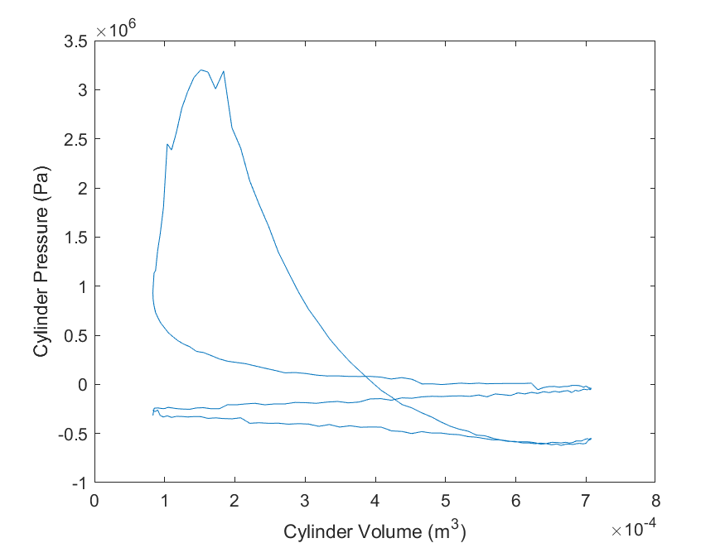

Figure 8 - Cylinder pressure vs. cylinder volume at 700 RPM for a single cycle

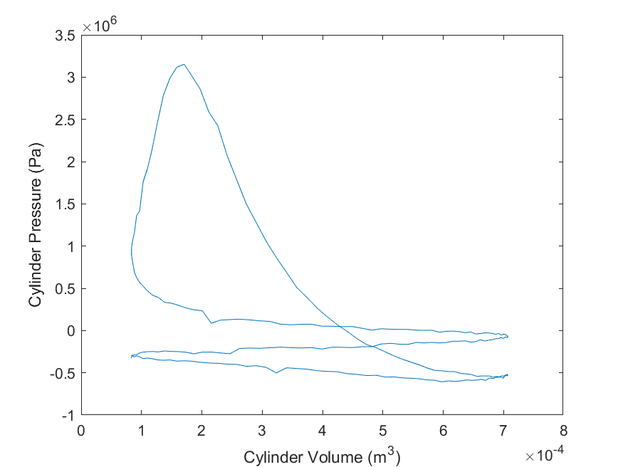

Figure 9 - Cylinder pressure vs. cylinder volume at 800 RPM for a single cycle

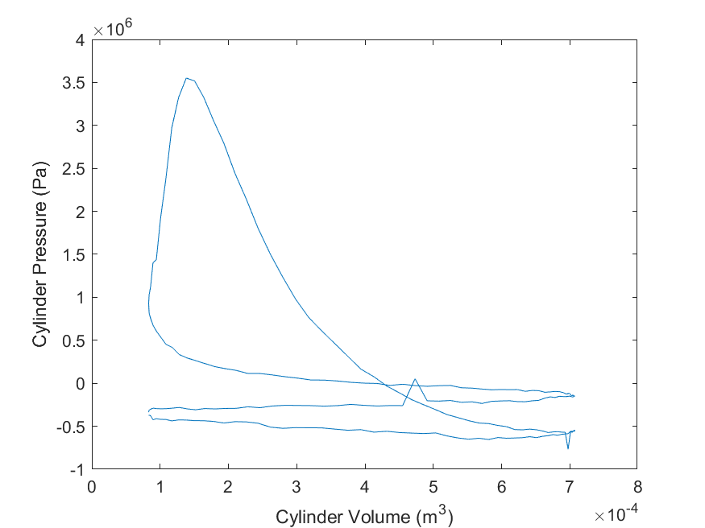

Figure 10 - Cylinder pressure vs. cylinder volume at 900 RPM for a single cycle

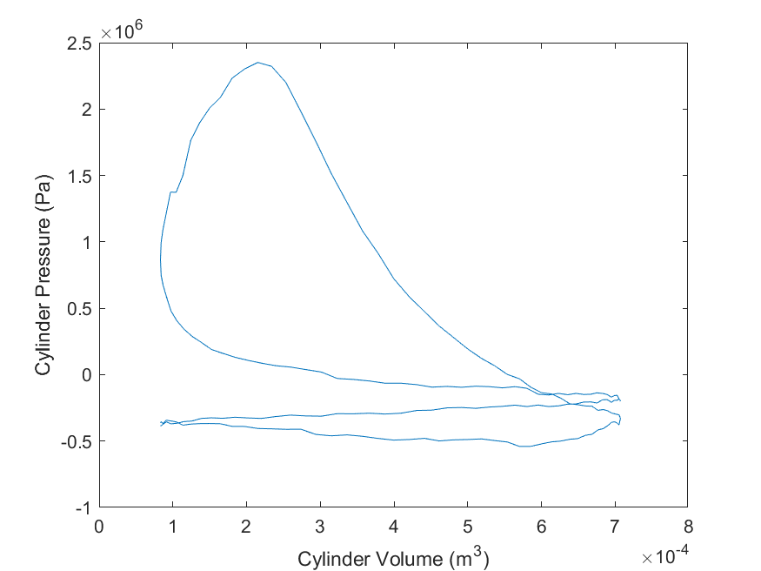

Figure 11 - Cylinder pressure vs. cylinder volume at 1000 RPM for a single cycle

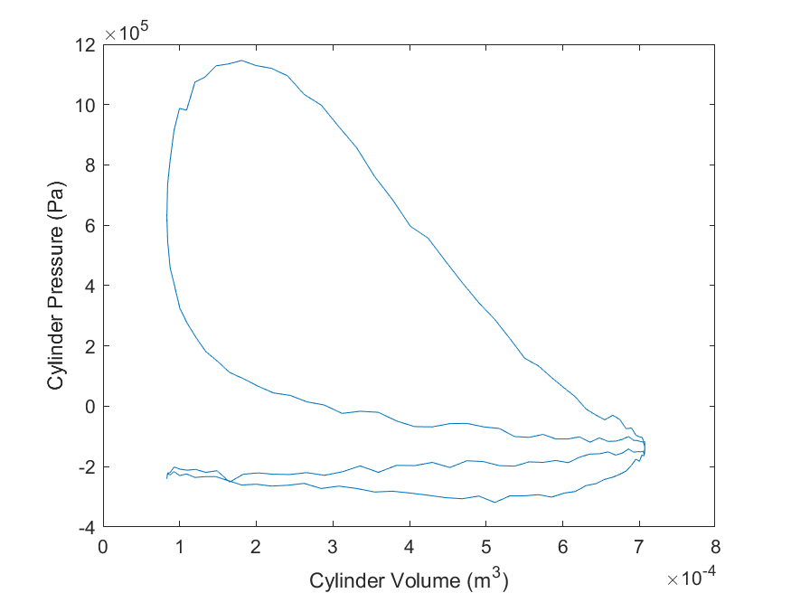

Figure 12 - Cylinder pressure vs. cylinder volume at 1100 RPM for a single cycle

# Pressure vs. Cylinder Volume for all Cycles

The following graphs detail all cycles of the engine at various engine speeds.

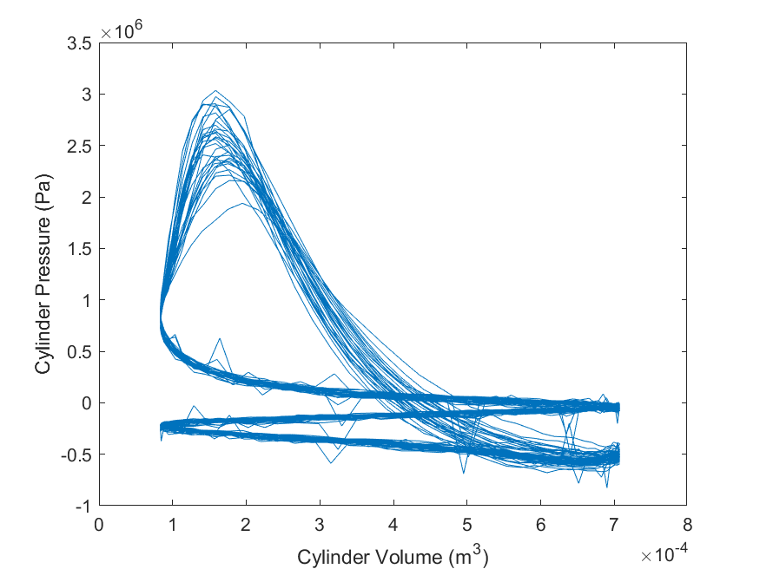

Figure 13 - Cylinder pressure vs. cylinder volume at 600 RPM for all cycles

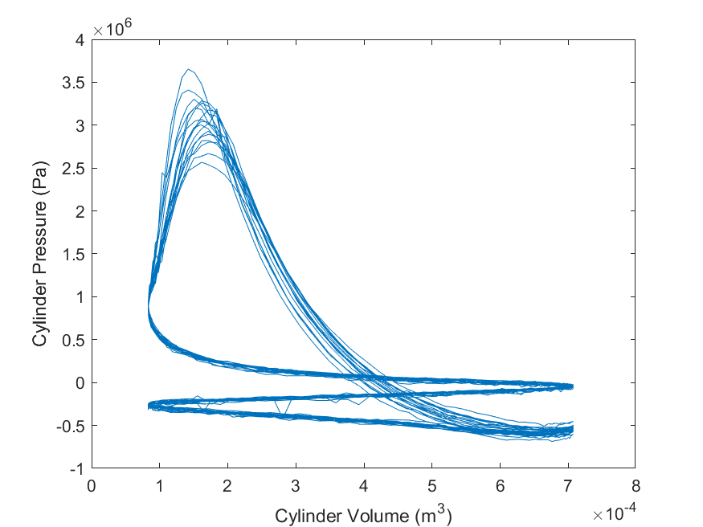

Figure 14 - Cylinder pressure vs. cylinder volume at 700 RPM for all cycles

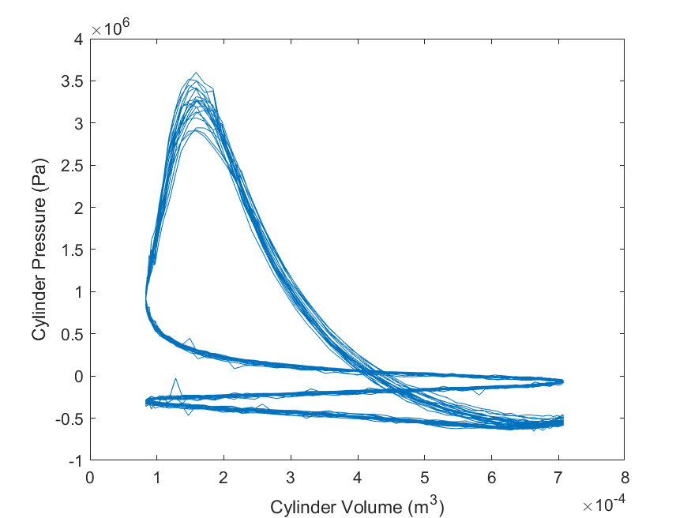

Figure 15 - Cylinder pressure vs. cylinder volume at 800 RPM for all cycles

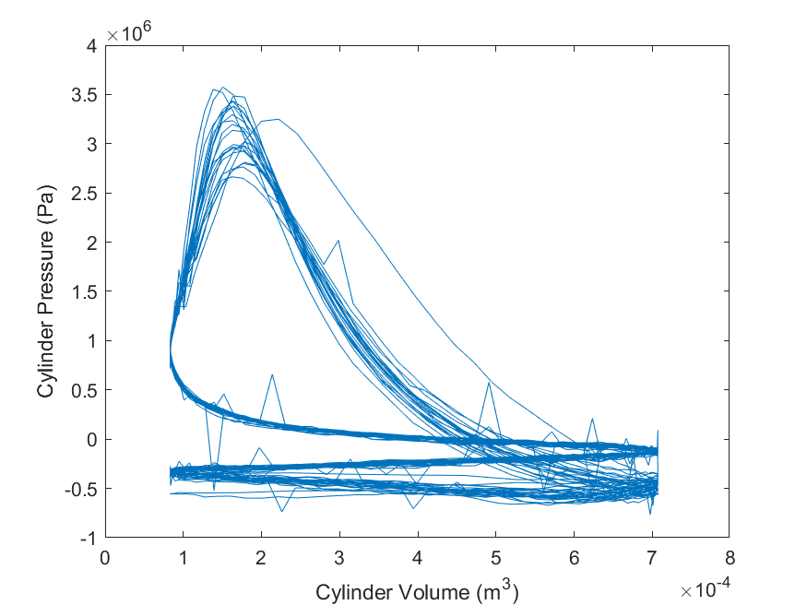

Figure 16 - Cylinder pressure vs. cylinder volume at 900 RPM for all cycles

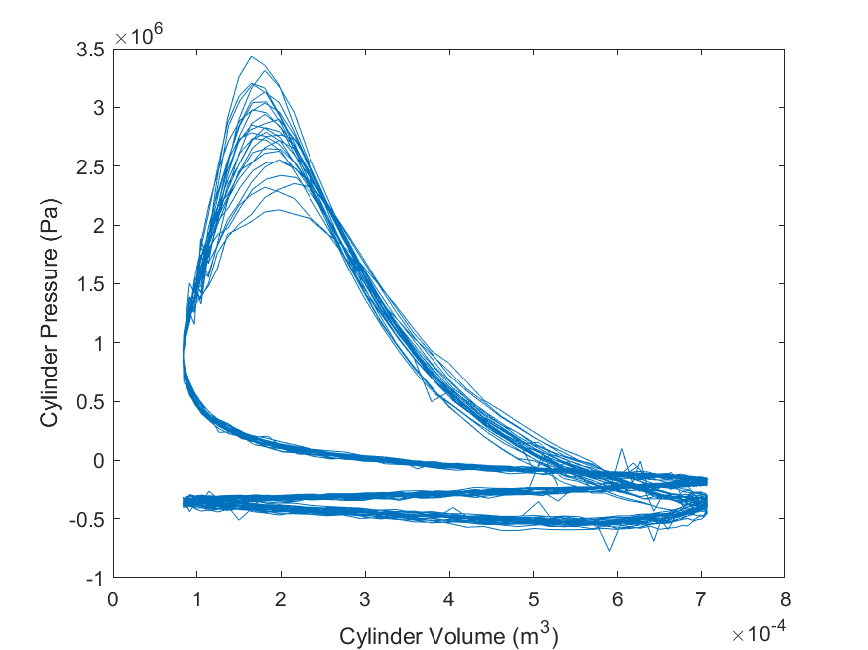

Figure 17 - Cylinder pressure vs. cylinder volume at 1000 RPM for all cycles

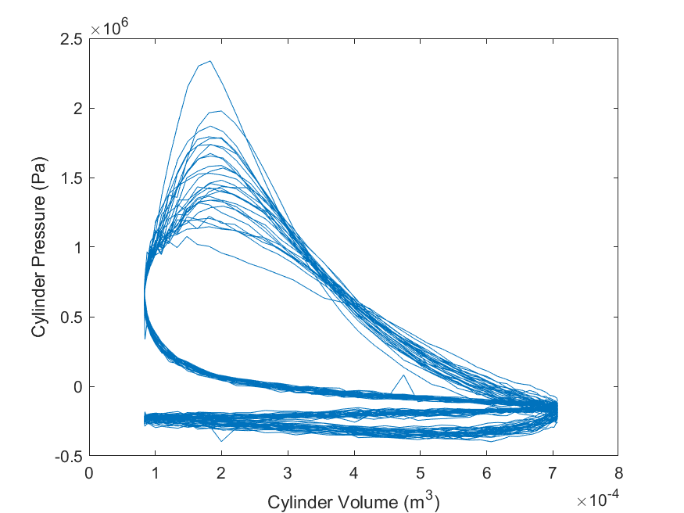

Figure 18 - Cylinder pressure vs. cylinder volume at 1100 RPM for all cycles

# Average Work and Power / Cycle / Cylinder for Various Engine Speeds

The following table details the calculated average work and power at various engine speeds with the calculated standard deviation of the data obtained.

|  |  |  |
| --- | --- | --- |
| RPM (1/min) | Work (J) | Power (W) |
| 600 | 233.1342 | 3681.948 |
| 700 | 253.8774 | 4677.063 |
| 800 | 274.2327 | 5775.736 |
| 900 | 286.7473 | 6780.336 |
| 1000 | 336.3609 | 8846.799 |
| 1100 | 230.9387 | 6686.308 |
| Standard Deviation | 39.60626 | 1806.906 |

# Engine Parameters

|  |  |  |  |  |  |
| --- | --- | --- | --- | --- | --- |
| RPM (1/min) | Mass Flow Rate (kg/cycle/cylinder) | Power (KW) | Torque (N-m) | Brake Efficiency ( ) | Conversion Efficiency ( ) |
| 600 | 2.70E-05 | 3.68 | 73.8 | 0.124 | 0.629 |
| 700 | 2.84E-05 | 4.68 | 80.3 | 0.127 | 0.630 |
| 800 | 2.74E-05 | 5.78 | 86.8 | 0.144 | 0.629 |
| 900 | 2.62E-05 | 6.78 | 90.7 | 0.151 | 0.631 |
| 1000 | 2.52E-05 | 8.85 | 106.4 | 0.190 | 0.630 |
| 1100 | 1.70E-05 | 6.69 | 73.1 | 0.225 | 0.630 |

# Brake Torque and Power with Engine Speed

The following graph plots the Brake Torque and Power of the engine as a function of the engine speed

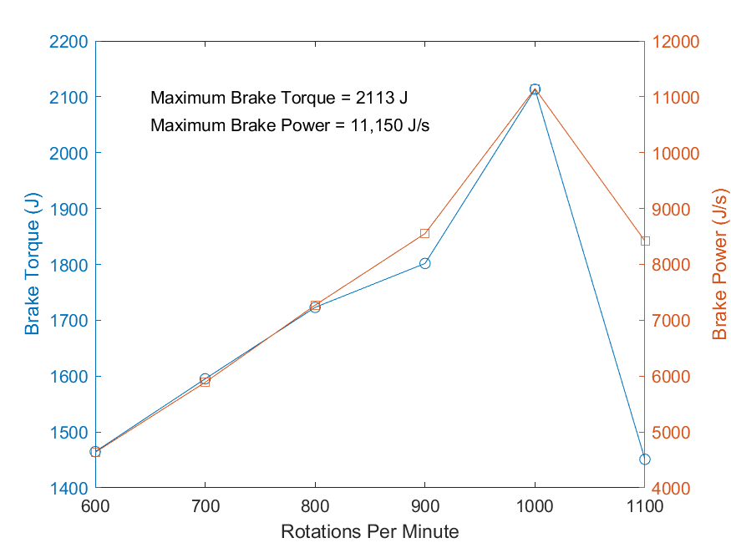

Figure 19 - Brake Torque and Power Values with different Rotational Engine Speeds

# Brake Thermal Efficiency with Various Engine Speeds

The following graphs displays the relation between the break thermal efficiency at different engine speeds

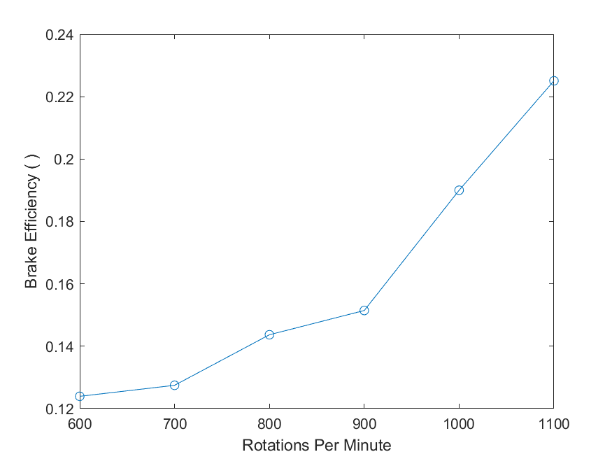

Figure 20 - The Brake Thermal Efficiency of the engine at different engine speeds

# Mass Flow Rate with Different Engine Speeds

Figures 21 and 22 provide the difference in mass flow rate with different engine speeds in kg/s and kg/cycle/cylinder, respectively.

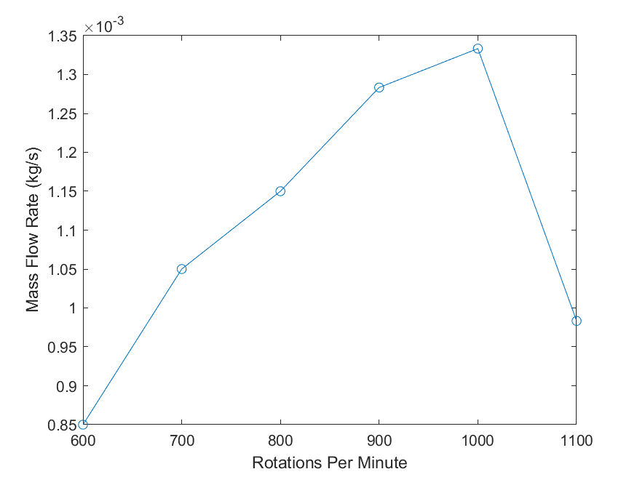

Figure 21 - Mass flow rate of the engine at different rotational speeds in kg/s

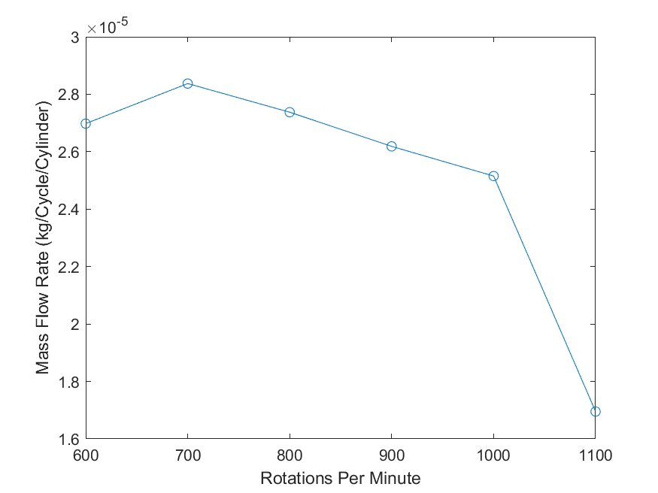

Figure 22 - Mass flow rate of the engine at different rotational speeds in kg/cycle/cylinder

# Appendix

% Engine Lab

clear all

close all

## Reading in Data

Reading in entire data set

Header=22;

RPM600 = importdata('600RPM.lvm' ,'\t',Header);

RPM700 = importdata('700RPM.lvm' ,'\t',Header);

RPM800 = importdata('800RPM.lvm' ,'\t',Header);

RPM900 = importdata('900RPM.lvm' ,'\t',Header);

RPM1000 = importdata('1000RPM.lvm','\t',Header);

RPM1100 = importdata('1100RPM.lvm','\t',Header);

% Separating entire data sets into vectors of Time and Voltage

RPM600_Volt = RPM600.data(:,2); % Optical Sensor (V)

RPM700_Volt = RPM700.data(:,2);

RPM800_Volt = RPM800.data(:,2);

RPM900_Volt = RPM900.data(:,2);

RPM1000_Volt = RPM1000.data(:,2);

RPM1100_Volt = RPM1100.data(:,2);

RPM600_Pres = RPM600.data(:,3); % p(V)

RPM700_Pres = RPM700.data(:,3);

RPM800_Pres = RPM800.data(:,3);

RPM900_Pres = RPM900.data(:,3);

RPM1000_Pres = RPM1000.data(:,3);

RPM1100_Pres = RPM1100.data(:,3);

## Contants for the Engine

vp_conv = 0.0104; % V/psi

CR = 8.5; % Compression Ratio

Rod_L = .116; % Meters

Stroke = .067; % Meters

Vol_Disp = 624/(1e6); % Cubic Meters

Vol_Clea = Vol_Disp/(CR-1); % Cubic Meters

R = 2*Rod_L/Stroke;

## 600 RPM

Power_600 = 10.3*745.7; % Watts

dm_600 = (13640-13589)/1000; % kilograms

RPM600P = (RPM600_Pres./vp_conv).*6894; % Pa

RPM600t = zeros(1,length(RPM600P));

for i = 1:length(RPM600t)

RPM600t(i) = RPM600t(i) + (i-1)*.0004;

end

RPM600t = RPM600t';

sw = 0;

j = 1;

thresh = 1;

n = length(RPM600_Volt);

for i = 1:n

if RPM600_Volt(i) - thresh > 0 && sw == 0

sw = 1;

pos_600(j) = i;

j = j + 1;

elseif RPM600_Volt(i) - thresh < 0 && sw == 1

sw = 0;

end

end

theta_600 = zeros(length(RPM600_Volt)-5,1);

for j = 1:length(pos_600)-1

for i = pos_600(j):pos_600(j+1)

theta_600(i) = 2*pi*(1 - ((RPM600t(pos_600(j+1)) - RPM600t(i))/(RPM600t(pos_600(j+1)) - RPM600t(pos_600(j)))));

end

end

Volume_600 = Vol_Clea.*(1+(.5.*(CR-1)).*(R+1-cos(theta_600)-sqrt(R.^2-(sin(theta_600)).^2)));

% Figure for Part 1a

f1 = figure(1);

subplot(3,1,3)

hold on

yyaxis left

plot(RPM600t(pos_600(1):pos_600(11)),RPM600P(pos_600(1):pos_600(11)))

ylabel('Pressure (Pa)')

yyaxis right

ylabel('Output Voltage (V)')

plot(RPM600t(pos_600(1):pos_600(11)),RPM600_Volt(pos_600(1):pos_600(11)))

subplot(3,1,1)

hold on

yyaxis left

plot(RPM600t(pos_600(1):pos_600(11)),theta_600(pos_600(1):pos_600(11)))

ylabel('Angle (Radians)')

yyaxis right

ylabel('Output Voltage (V)')

plot(RPM600t(pos_600(1):pos_600(11)),RPM600_Volt(pos_600(1):pos_600(11)))

subplot(3,1,2)

hold on

yyaxis left

plot(RPM600t(pos_600(1):pos_600(11)),Volume_600(pos_600(1):pos_600(11)))

ylabel('Volume (m^3)')

yyaxis right

ylabel('Output Voltage (V)')

plot(RPM600t(pos_600(1):pos_600(11)),RPM600_Volt(pos_600(1):pos_600(11)))

xlabel('Time (Sec)')

% Figure for part 1b

f2=figure(2);

plot(Volume_600(pos_600(3):pos_600(5)),RPM600P(pos_600(3):pos_600(5)))

xlabel('Cylinder Volume (m^3)')

ylabel('Cylinder Pressure (Pa)')

% Figure for part 1c

f3=figure(3);

plot(Volume_600(pos_600(3):pos_600(end)),RPM600P(pos_600(3):pos_600(end)))

xlabel('Cylinder Volume (m^3)')

ylabel('Cylinder Pressure (Pa)')

% Part 2

j=1;

W = zeros(10,1);

P = zeros(10,1);

for i = 1:2:19

W(j) = trapz(Volume_600(pos_600(i):pos_600(i+2)),RPM600P(pos_600(i):pos_600(i+2)))/2;

P(j) = W(j)/(RPM600t(pos_600(i+2))-RPM600t(pos_600(i)));

j=j+1;

end

Avg_W_600 = mean(W);

Avg_P_600 = mean(P);

MFR1 = dm_600/(60/RPM600t(end));

MFR = MFR1/(length(pos_600)/2);

MFR2_600 = dm_600/60;

MFR_Cyl_600 = MFR/2; % Flow rate of one cylinder per cycle

KW_600 = Avg_P_600/1000; % Power in KW

Torque_600 = Avg_W_600/3.16; % Engine Torque

Brake_Power_600 = 2*pi*(600/60)*Torque_600;

Brake_Eff_600 = Brake_Power_600/(MFR2_600*(44e6)); % Brake thermal eff

Conv_Eff_600 = Brake_Power_600/(Avg_P_600*2); % Mechanical conversion eff

## 700 RPM

Power_700 = 12.8*745.7; % Watts

dm_700 = (13729-13666)/1000; % kilograms

RPM700P = (RPM700_Pres./vp_conv).*6894; % Pa

RPM700t = zeros(1,length(RPM700P));

for i = 1:length(RPM700t)

RPM700t(i) = RPM700t(i) + (i-1)*.0002;

end

RPM700t = RPM700t';

sw = 0;

j = 1;

thresh = 1;

n = length(RPM700_Volt);

for i = 1:n

if RPM700_Volt(i) - thresh > 0 && sw == 0

sw = 1;

pos_700(j) = i;

j = j + 1;

elseif RPM700_Volt(i) - thresh < 0 && sw == 1

sw = 0;

end

end

theta_700 = zeros(length(RPM700_Volt)-5,1);

for j = 1:length(pos_700)-1

for i = pos_700(j):pos_700(j+1)

theta_700(i) = 2*pi*(1 - ((RPM700t(pos_700(j+1)) - RPM700t(i))/(RPM700t(pos_700(j+1)) - RPM700t(pos_700(j)))));

end

end

Volume_700 = Vol_Clea.*(1+(.5.*(CR-1)).*(R+1-cos(theta_700)-sqrt(R.^2-(sin(theta_700)).^2)));

% Figure for Part 1a

f4=figure(4);

subplot(3,1,3)

hold on

yyaxis left

plot(RPM700t(pos_700(1):pos_700(11)),RPM700P(pos_700(1):pos_700(11)))

ylabel('Pressure (Pa)')

yyaxis right

ylabel('Output Voltage (V)')

plot(RPM700t(pos_700(1):pos_700(11)),RPM700_Volt(pos_700(1):pos_700(11)))

subplot(3,1,1)

hold on

yyaxis left

plot(RPM700t(pos_700(1):pos_700(11)),theta_700(pos_700(1):pos_700(11)))

ylabel('Angle (Radians)')

yyaxis right

ylabel('Output Voltage (V)')

plot(RPM700t(pos_700(1):pos_700(11)),RPM700_Volt(pos_700(1):pos_700(11)))

subplot(3,1,2)

hold on

yyaxis left

plot(RPM700t(pos_700(1):pos_700(11)),Volume_700(pos_700(1):pos_700(11)))

ylabel('Volume (m^3)')

yyaxis right

ylabel('Output Voltage (V)')

plot(RPM700t(pos_700(1):pos_700(11)),RPM700_Volt(pos_700(1):pos_700(11)))

xlabel('Time (Sec)')

% Figure for part 1b

f18=figure(18);

plot(Volume_700(pos_700(3):pos_700(5)),RPM700P(pos_700(3):pos_700(5)))

xlabel('Cylinder Volume (m^3)')

ylabel('Cylinder Pressure (Pa)')

% Figure for part 1c

f5=figure(5);

plot(Volume_700(pos_700(3):pos_700(end)),RPM700P(pos_700(3):pos_700(end)))

xlabel('Cylinder Volume (m^3)')

ylabel('Cylinder Pressure (Pa)')

% Part 2

j=1;

W = zeros(10,1);

P = zeros(10,1);

for i = 1:2:19

W(j) = trapz(Volume_700(pos_700(i):pos_700(i+2)),RPM700P(pos_700(i):pos_700(i+2)))/2;

P(j) = W(j)/(RPM700t(pos_700(i+2))-RPM700t(pos_700(i)));

j=j+1;

end

Avg_W_700 = mean(W);

Avg_P_700 = mean(P);

MFR = (dm_700/(60/RPM700t(end)))/(length(pos_700)/2);

%MFR = ((dm_700/(60/RPM700t(end)))/(length(pos_700)/2));

MFR2_700 = dm_700/60;

MFR_Cyl_700 = MFR/2; % Flow rate of one cylinder per cycle

KW_700 = Avg_P_700/1000; % Power in KW

Torque_700 = Avg_W_700/3.16; % Engine Torque

Brake_Power_700 = 2*pi*(700/60)*Torque_700;

Brake_Eff_700 = Brake_Power_700/(MFR2_700*(44e6)); % Brake thermal eff

Conv_Eff_700 = Brake_Power_700/(Avg_P_700*2); % Mechanical conversion eff

## 800 RPM

Power_800 = 14.9*745.7; % Watts

dm_800 = (13829-13760)/1000; % kilograms

RPM800P = (RPM800_Pres./vp_conv).*6894; % Pa

RPM800t = zeros(1,length(RPM800P));

for i = 1:length(RPM800t)

RPM800t(i) = RPM800t(i) + (i-1)*.0002;

end

RPM800t = RPM800t';

sw = 0;

j = 1;

thresh = 1;

n = length(RPM800_Volt);

for i = 1:n

if RPM800_Volt(i) - thresh > 0 && sw == 0

sw = 1;

pos_800(j) = i;

j = j + 1;

elseif RPM800_Volt(i) - thresh < 0 && sw == 1

sw = 0;

end

end

theta_800 = zeros(length(RPM800_Volt)-5,1);

for j = 1:length(pos_800)-1

for i = pos_800(j):pos_800(j+1)

theta_800(i) = 2*pi*(1 - ((RPM800t(pos_800(j+1)) - RPM800t(i))/(RPM800t(pos_800(j+1)) - RPM800t(pos_800(j)))));

end

end

Volume_800 = Vol_Clea.*(1+(.5.*(CR-1)).*(R+1-cos(theta_800)-sqrt(R.^2-(sin(theta_800)).^2)));

% Figure for Part 1a

f6=figure(6);

subplot(3,1,3)

hold on

yyaxis left

plot(RPM800t(pos_800(1):pos_800(11)),RPM800P(pos_800(1):pos_800(11)))

ylabel('Pressure (Pa)')

yyaxis right

ylabel('Output Voltage (V)')

plot(RPM800t(pos_800(1):pos_800(11)),RPM800_Volt(pos_800(1):pos_800(11)))

subplot(3,1,1)

hold on

yyaxis left

plot(RPM800t(pos_800(1):pos_800(11)),theta_800(pos_800(1):pos_800(11)))

ylabel('Angle (Radians)')

yyaxis right

ylabel('Output Voltage (V)')

plot(RPM800t(pos_800(1):pos_800(11)),RPM800_Volt(pos_800(1):pos_800(11)))

subplot(3,1,2)

hold on

yyaxis left

plot(RPM800t(pos_800(1):pos_800(11)),Volume_800(pos_800(1):pos_800(11)))

ylabel('Volume (m^3)')

yyaxis right

ylabel('Output Voltage (V)')

plot(RPM800t(pos_800(1):pos_800(11)),RPM800_Volt(pos_800(1):pos_800(11)))

xlabel('Time (Sec)')

% Figure for part 1b

f19=figure(19);

plot(Volume_800(pos_800(3):pos_800(5)),RPM800P(pos_800(3):pos_800(5)))

xlabel('Cylinder Volume (m^3)')

ylabel('Cylinder Pressure (Pa)')

% Figure for part 1c

f7=figure(7);

plot(Volume_800(pos_800(3):pos_800(end)),RPM800P(pos_800(3):pos_800(end)))

xlabel('Cylinder Volume (m^3)')

ylabel('Cylinder Pressure (Pa)')

% Part 2

j=1;

W = zeros(10,1);

P = zeros(10,1);

for i = 1:2:19

W(j) = trapz(Volume_800(pos_800(i):pos_800(i+2)),RPM800P(pos_800(i):pos_800(i+2)))/2;

P(j) = W(j)/(RPM800t(pos_800(i+2))-RPM800t(pos_800(i)));

j=j+1;

end

Avg_W_800 = mean(W);

Avg_P_800 = mean(P);

MFR = (dm_800/(60/RPM800t(end)))/(length(pos_800)/2);

%MFR = ((dm_800/(60/RPM800t(end)))/(length(pos_800)/2));

MFR2_800 = dm_800/60;

MFR_Cyl_800 = MFR/2; % Flow rate of one cylinder per cycle

KW_800 = Avg_P_800/1000; % Power in KW

Torque_800 = Avg_W_800/3.16; % Engine Torque

Brake_Power_800 = 2*pi*(800/60)*Torque_800;

Brake_Eff_800 = Brake_Power_800/(MFR2_800*(44e6)); % Brake thermal eff

Conv_Eff_800 = Brake_Power_800/(Avg_P_800*2); % Mechanical conversion eff

## 900 RPM

Power_900 = 16.6*745.7; % Watts

dm_900 = (13941-13864)/1000; % kilograms

RPM900P = (RPM900_Pres./vp_conv).*6894; % Pa

RPM900t = zeros(1,length(RPM900P));

for i = 1:length(RPM900t)

RPM900t(i) = RPM900t(i) + (i-1)*.0002;

end

RPM900t = RPM900t';

sw = 0;

j = 1;

thresh = 1;

n = length(RPM900_Volt);

for i = 1:n

if RPM900_Volt(i) - thresh > 0 && sw == 0

sw = 1;

pos_900(j) = i;

j = j + 1;

elseif RPM900_Volt(i) - thresh < 0 && sw == 1

sw = 0;

end

end

theta_900 = zeros(length(RPM900_Volt)-5,1);

for j = 1:length(pos_900)-1

for i = pos_900(j):pos_900(j+1)

theta_900(i) = 2*pi*(1 - ((RPM900t(pos_900(j+1)) - RPM900t(i))/(RPM900t(pos_900(j+1)) - RPM900t(pos_900(j)))));

end

end

Volume_900 = Vol_Clea.*(1+(.5.*(CR-1)).*(R+1-cos(theta_900)-sqrt(R.^2-(sin(theta_900)).^2)));

% Figure for Part 1a

f8=figure(8);

subplot(3,1,3)

hold on

yyaxis left

plot(RPM900t(pos_900(1):pos_900(11)),RPM900P(pos_900(1):pos_900(11)))

ylabel('Pressure (V)')

yyaxis right

ylabel('Output Voltage (V)')

plot(RPM900t(pos_900(1):pos_900(11)),RPM900_Volt(pos_900(1):pos_900(11)))

subplot(3,1,1)

hold on

yyaxis left

plot(RPM900t(pos_900(1):pos_900(11)),theta_900(pos_900(1):pos_900(11)))

ylabel('Angle (Radians)')

yyaxis right

ylabel('Output Voltage (V)')

plot(RPM900t(pos_900(1):pos_900(11)),RPM900_Volt(pos_900(1):pos_900(11)))

subplot(3,1,2)

hold on

yyaxis left

plot(RPM900t(pos_900(1):pos_900(11)),Volume_900(pos_900(1):pos_900(11)))

ylabel('Volume (m^3)')

yyaxis right

ylabel('Output Voltage (V)')

plot(RPM900t(pos_900(1):pos_900(11)),RPM900_Volt(pos_900(1):pos_900(11)))

xlabel('Time (Sec)')

% Figure for part 1b

f20=figure(20);

plot(Volume_900(pos_900(3):pos_900(5)),RPM900P(pos_900(3):pos_900(5)))

xlabel('Cylinder Volume (m^3)')

ylabel('Cylinder Pressure (Pa)')

% Figure for part 1c

f9=figure(9);

plot(Volume_900(pos_900(3):pos_900(end)),RPM900P(pos_900(3):pos_900(end)))

xlabel('Cylinder Volume (m^3)')

ylabel('Cylinder Pressure (Pa)')

% Part 2

j=1;

W = zeros(10,1);

P = zeros(10,1);

for i = 1:2:19

W(j) = trapz(Volume_900(pos_900(i):pos_900(i+2)),RPM900P(pos_900(i):pos_900(i+2)))/2;

P(j) = W(j)/(RPM900t(pos_900(i+2))-RPM900t(pos_900(i)));

j=j+1;

end

Avg_W_900 = mean(W);

Avg_P_900 = mean(P);

MFR = (dm_900/(60/RPM900t(end)))/(length(pos_900)/2);

%MFR = ((dm_900/(60/RPM900t(end)))/(length(pos_900)/2));

MFR2_900 = dm_900/60;

MFR_Cyl_900 = MFR/2; % Flow rate of one cylinder per cycle

KW_900 = Avg_P_900/1000 ;% Power in KW

Torque_900 = Avg_W_900/3.16; % Engine Torque

Brake_Power_900 = 2*pi*(900/60)*Torque_900;

Brake_Eff_900 = Brake_Power_900/(MFR2_900*(44e6)); % Brake thermal eff

Conv_Eff_900 = Brake_Power_900/(Avg_P_900*2); % Mechanical conversion eff

## 1000 RPM

Power_1000 = 17.7*745.7; % Watts

dm_1000 = (14056-13976)/1000; % kilograms

RPM1000P = (RPM1000_Pres./vp_conv).*6894; % Pa

RPM1000t = zeros(1,length(RPM1000P));

for i = 1:length(RPM1000t)

RPM1000t(i) = RPM1000t(i) + (i-1)*.0002;

end

RPM1000t = RPM1000t';

sw = 0;

j = 1;

thresh = 1;

n = length(RPM1000_Volt);

for i = 1:n

if RPM1000_Volt(i) - thresh > 0 && sw == 0

sw = 1;

pos_1000(j) = i;

j = j + 1;

elseif RPM1000_Volt(i) - thresh < 0 && sw == 1

sw = 0;

end

end

theta_1000 = zeros(length(RPM1000_Volt)-5,1);

for j = 1:length(pos_1000)-1

for i = pos_1000(j):pos_1000(j+1)

theta_1000(i) = 2*pi*(1 - ((RPM1000t(pos_1000(j+1)) - RPM1000t(i))/(RPM1000t(pos_1000(j+1)) - RPM1000t(pos_1000(j)))));

end

end

Volume_1000 = Vol_Clea.*(1+(.5.*(CR-1)).*(R+1-cos(theta_1000)-sqrt(R.^2-(sin(theta_1000)).^2)));

% Figure for Part 1a

f10=figure(10);

subplot(3,1,3)

hold on

yyaxis left

plot(RPM1000t(pos_1000(1):pos_1000(11)),RPM1000P(pos_1000(1):pos_1000(11)))

ylabel('Pressure (Pa)')

yyaxis right

ylabel('Output Voltage (V)')

plot(RPM1000t(pos_1000(1):pos_1000(11)),RPM1000_Volt(pos_1000(1):pos_1000(11)))

subplot(3,1,1)

hold on

yyaxis left

plot(RPM1000t(pos_1000(1):pos_1000(11)),theta_1000(pos_1000(1):pos_1000(11)))

ylabel('Angle (Radians)')

yyaxis right

ylabel('Output Voltage (V)')

plot(RPM1000t(pos_1000(1):pos_1000(11)),RPM1000_Volt(pos_1000(1):pos_1000(11)))

subplot(3,1,2)

hold on

yyaxis left

plot(RPM1000t(pos_1000(1):pos_1000(11)),Volume_1000(pos_1000(1):pos_1000(11)))

ylabel('Volume (m^3)')

yyaxis right

ylabel('Output Voltage (V)')

plot(RPM1000t(pos_1000(1):pos_1000(11)),RPM1000_Volt(pos_1000(1):pos_1000(11)))

xlabel('Time (Sec)')

% Figure for part 1b

f21=figure(21);

plot(Volume_1000(pos_1000(3):pos_1000(5)),RPM1000P(pos_1000(3):pos_1000(5)))

xlabel('Cylinder Volume (m^3)')

ylabel('Cylinder Pressure (Pa)')

% Figure for part 1c

f11=figure(11);

plot(Volume_1000(pos_1000(3):pos_1000(end)),RPM1000P(pos_1000(3):pos_1000(end)))

xlabel('Cylinder Volume (m^3)')

ylabel('Cylinder Pressure (Pa)')

% Part 2

j=1;

W = zeros(10,1);

P = zeros(10,1);

for i = 1:2:19

W(j) = trapz(Volume_1000(pos_1000(i):pos_1000(i+2)),RPM1000P(pos_1000(i):pos_1000(i+2)))/2;

P(j) = W(j)/(RPM1000t(pos_1000(i+2))-RPM1000t(pos_1000(i)));

j=j+1;

end

Avg_W_1000 = mean(W);

Avg_P_1000 = mean(P);

MFR = (dm_1000/(60/RPM1000t(end)))/(length(pos_1000)/2);

%MFR = ((dm_1000/(60/RPM1000t(end)))/(length(pos_1000)/2));

MFR2_1000 = dm_1000/60;

MFR_Cyl_1000 = MFR/2; % Flow rate of one cylinder per cycle

KW_1000 = Avg_P_1000/1000; % Power in KW

Torque_1000 = Avg_W_1000/3.16; % Engine Torque

Brake_Power_1000 = 2*pi*(1000/60)*Torque_1000;

Brake_Eff_1000 = Brake_Power_1000/(MFR2_1000*(44e6)); % Brake thermal eff

Conv_Eff_1000 = Brake_Power_1000/(Avg_P_1000*2); % Mechanical conversion eff

## 1100 RPM

Power_1100 = 12*745.7; % Watts

dm_1100 = (14156-14097)/1000; % kilograms

RPM1100P = (RPM1100_Pres./vp_conv).*6894; % Pa

RPM1100t = zeros(1,length(RPM1100P));

for i = 1:length(RPM1100t)

RPM1100t(i) = RPM1100t(i) + (i-1)*.0002;

end

RPM1100t = RPM1100t';

sw = 0;

j = 1;

thresh = 1;

n = length(RPM1100_Volt);

for i = 1:n

if RPM1100_Volt(i) - thresh > 0 && sw == 0

sw = 1;

pos_1100(j) = i;

j = j + 1;

elseif RPM1100_Volt(i) - thresh < 0 && sw == 1

sw = 0;

end

end

theta_1100 = zeros(length(RPM1100_Volt)-5,1);

for j = 1:length(pos_1100)-1

for i = pos_1100(j):pos_1100(j+1)

theta_1100(i) = 2*pi*(1 - ((RPM1100t(pos_1100(j+1)) - RPM1100t(i))/(RPM1100t(pos_1100(j+1)) - RPM1100t(pos_1100(j)))));

end

end

Volume_1100 = Vol_Clea.*(1+(.5.*(CR-1)).*(R+1-cos(theta_1100)-sqrt(R.^2-(sin(theta_1100)).^2)));

% Figure for Part 1a

f12=figure(12);

subplot(3,1,3)

hold on

yyaxis left

plot(RPM1100t(pos_1100(1):pos_1100(11)),RPM1100P(pos_1100(1):pos_1100(11)))

ylabel('Pressure (Pa)')

yyaxis right

ylabel('Output Voltage (V)')

plot(RPM1100t(pos_1100(1):pos_1100(11)),RPM1100_Volt(pos_1100(1):pos_1100(11)))

subplot(3,1,1)

hold on

yyaxis left

plot(RPM1100t(pos_1100(1):pos_1100(11)),theta_1100(pos_1100(1):pos_1100(11)))

ylabel('Angle (Radians)')

yyaxis right

ylabel('Output Voltage (V)')

plot(RPM1100t(pos_1100(1):pos_1100(11)),RPM1100_Volt(pos_1100(1):pos_1100(11)))

subplot(3,1,2)

hold on

yyaxis left

plot(RPM1100t(pos_1100(1):pos_1100(11)),Volume_1100(pos_1100(1):pos_1100(11)))

ylabel('Volume (m^3)')

yyaxis right

ylabel('Output Voltage (V)')

plot(RPM1100t(pos_1100(1):pos_1100(11)),RPM1100_Volt(pos_1100(1):pos_1100(11)))

xlabel('Time (Sec)')

% Figure for part 1b

f22=figure(22);

plot(Volume_1100(pos_1100(3):pos_1100(5)),RPM1100P(pos_1100(3):pos_1100(5)))

xlabel('Cylinder Volume (m^3)')

ylabel('Cylinder Pressure (Pa)')

% Figure for part 1c

f13=figure(13);

plot(Volume_1100(pos_1100(3):pos_1100(end)),RPM1100P(pos_1100(3):pos_1100(end)))

xlabel('Cylinder Volume (m^3)')

ylabel('Cylinder Pressure (Pa)')

% Part 2

j=1;

W = zeros(10,1);

P = zeros(10,1);

for i = 1:2:19

W(j) = trapz(Volume_1100(pos_1100(i):pos_1100(i+2)),RPM1100P(pos_1100(i):pos_1100(i+2)))/2;

P(j) = W(j)/(RPM1100t(pos_1100(i+2))-RPM1100t(pos_1100(i)));

j=j+1;

end

Avg_W_1100 = mean(W);

Avg_P_1100 = mean(P);

MFR = (dm_1100/(60/RPM1100t(end)))/(length(pos_1100)/2);

%MFR = ((dm_1100/(60/RPM1100t(end)))/(length(pos_1100)/2));

MFR2_1100 = dm_1100/60;

MFR_Cyl_1100 = MFR/2; % Flow rate of one cylinder per cycle

KW_1100 = Avg_P_1100/1000; % Power in KW

Torque_1100 = Avg_W_1100/3.16; % Engine Torque

Brake_Power_1100 = 2*pi*(1100/60)*Torque_1100;

Brake_Eff_1100 = Brake_Power_1100/(MFR2_600*(44e6)); % Brake thermal eff

Conv_Eff_1100 = Brake_Power_1100/(Avg_P_1100*2); % Mechanical conversion eff

## Final Calculations and Tables

Work = [Avg_W_600;Avg_W_700;Avg_W_800;Avg_W_900;Avg_W_1000;Avg_W_1100];

Power = [Avg_P_600;Avg_P_700;Avg_P_800;Avg_P_900;Avg_P_1000;Avg_P_1100];

Std_Work = std(Work);

Std_Power = std(Power);

RPM = ["600";"700";"800";"900";"1000";"1100";"Standard Deviation"]; % rotations per minute

Work = [Avg_W_600;Avg_W_700;Avg_W_800;Avg_W_900;Avg_W_1000;Avg_W_1100;Std_Work];

Power = [Avg_P_600;Avg_P_700;Avg_P_800;Avg_P_900;Avg_P_1000;Avg_P_1100;Std_Power];

T1 = table(RPM,Work,Power);

RPM = ["600";"700";"800";"900";"1000";"1100"]; % rotations per minute

MFR = [MFR_Cyl_600;MFR_Cyl_700;MFR_Cyl_800;MFR_Cyl_900;MFR_Cyl_1000;MFR_Cyl_1100]; % Mass flow rate kg/s

Power = [KW_600;KW_700;KW_800;KW_900;KW_1000;KW_1100]; % power in KW

Torque = [Torque_600;Torque_700;Torque_800;Torque_900;Torque_1000;Torque_1100]; % N-m

Brake_Efficiency = [Brake_Eff_600;Brake_Eff_700;Brake_Eff_800;Brake_Eff_900;Brake_Eff_1000;Brake_Eff_1100];

Conversion_Efficieny = [Conv_Eff_600;Conv_Eff_700;Conv_Eff_800;Conv_Eff_900;Conv_Eff_1000;Conv_Eff_1100];

T2 = table(RPM,MFR,Power,Torque,Brake_Efficiency,Conversion_Efficieny);

## Plotting End Results

Work = [Avg_W_600;Avg_W_700;Avg_W_800;Avg_W_900;Avg_W_1000;Avg_W_1100];

RPM = [600;700;800;900;1000;1100]; % rotations per minute

BrakeTorque = 2*pi.*Work;

Torque = [Torque_600,Torque_700,Torque_800,Torque_900,Torque_1000,Torque_1100];

for i = 1:length(Torque)

BrakePower(i) = 2*pi.*(RPM(i)/60).*Torque(i);

end

f14=figure(14);

yyaxis left

plot(RPM,BrakeTorque,'-o')

ylabel('Brake Torque (J)')

hold on

yyaxis right

plot(RPM,BrakePower,'-s')

ylabel('Brake Power (J/s)')

xlabel('Rotations Per Minute')

text(650,11000,'Maximum Brake Torque = 2113 J')

text(650,10500,'Maximum Brake Power = 11,150 J/s')

f15=figure(15);

plot(RPM,Brake_Efficiency,'-o')

xlabel('Rotations Per Minute')

ylabel('Brake Efficiency ( )')

f16 = figure(16);

plot(RPM,MFR,'-o')

xlabel('Rotations Per Minute')

ylabel('Mass Flow Rate (kg/Cycle/Cylinder)')

MFR2 = [MFR2_600,MFR2_700,MFR2_800,MFR2_900,MFR2_1000,MFR2_1100];

f17 = figure(17);

plot(RPM,MFR2,'-o')

xlabel('Rotations Per Minute')

ylabel('Mass Flow Rate (kg/s)')

## Saving Figures

saveas(f1, 'C:\Users\User\Desktop\Charlie\Classes\Junior Year\Spring 2019\J-Lab\Lab 5\Figures\subplot600.png','png');

saveas(f2, 'C:\Users\User\Desktop\Charlie\Classes\Junior Year\Spring 2019\J-Lab\Lab 5\Figures\onecycle600.png','png');

saveas(f3, 'C:\Users\User\Desktop\Charlie\Classes\Junior Year\Spring 2019\J-Lab\Lab 5\Figures\allcycle600.png','png');

saveas(f4, 'C:\Users\User\Desktop\Charlie\Classes\Junior Year\Spring 2019\J-Lab\Lab 5\Figures\subplot700.png','png');

saveas(f5, 'C:\Users\User\Desktop\Charlie\Classes\Junior Year\Spring 2019\J-Lab\Lab 5\Figures\allcycle700.png','png');

saveas(f6, 'C:\Users\User\Desktop\Charlie\Classes\Junior Year\Spring 2019\J-Lab\Lab 5\Figures\subplot800.png','png');

saveas(f7, 'C:\Users\User\Desktop\Charlie\Classes\Junior Year\Spring 2019\J-Lab\Lab 5\Figures\allcycle800.png','png');

saveas(f8, 'C:\Users\User\Desktop\Charlie\Classes\Junior Year\Spring 2019\J-Lab\Lab 5\Figures\subplot900.png','png');

saveas(f9, 'C:\Users\User\Desktop\Charlie\Classes\Junior Year\Spring 2019\J-Lab\Lab 5\Figures\allcycle900.png','png');

saveas(f10, 'C:\Users\User\Desktop\Charlie\Classes\Junior Year\Spring 2019\J-Lab\Lab 5\Figures\subplot1000.png','png');

saveas(f11, 'C:\Users\User\Desktop\Charlie\Classes\Junior Year\Spring 2019\J-Lab\Lab 5\Figures\allcycle1000.png','png');

saveas(f12, 'C:\Users\User\Desktop\Charlie\Classes\Junior Year\Spring 2019\J-Lab\Lab 5\Figures\subplot1100.png','png');

saveas(f13, 'C:\Users\User\Desktop\Charlie\Classes\Junior Year\Spring 2019\J-Lab\Lab 5\Figures\allcycle1100.png','png');

saveas(f14, 'C:\Users\User\Desktop\Charlie\Classes\Junior Year\Spring 2019\J-Lab\Lab 5\Figures\braketorquepower.png','png');

saveas(f15, 'C:\Users\User\Desktop\Charlie\Classes\Junior Year\Spring 2019\J-Lab\Lab 5\Figures\thermaleff.png','png');

saveas(f16, 'C:\Users\User\Desktop\Charlie\Classes\Junior Year\Spring 2019\J-Lab\Lab 5\Figures\mfr.png','png');

saveas(f17, 'C:\Users\User\Desktop\Charlie\Classes\Junior Year\Spring 2019\J-Lab\Lab 5\Figures\mfgkgs.png','png');

saveas(f18, 'C:\Users\User\Desktop\Charlie\Classes\Junior Year\Spring 2019\J-Lab\Lab 5\Figures\onecycle700.png','png');

saveas(f19, 'C:\Users\User\Desktop\Charlie\Classes\Junior Year\Spring 2019\J-Lab\Lab 5\Figures\onecycle800.png','png');

saveas(f20, 'C:\Users\User\Desktop\Charlie\Classes\Junior Year\Spring 2019\J-Lab\Lab 5\Figures\onecycle900.png','png');

saveas(f21, 'C:\Users\User\Desktop\Charlie\Classes\Junior Year\Spring 2019\J-Lab\Lab 5\Figures\onecycle1000.png','png');

saveas(f22, 'C:\Users\User\Desktop\Charlie\Classes\Junior Year\Spring 2019\J-Lab\Lab 5\Figures\onecycle1100.png','png');